**CURRICULUM VITAE**

|  |
| --- |
| PERSONAL IDENTIFICATION |

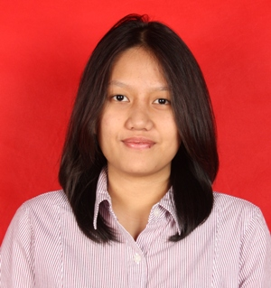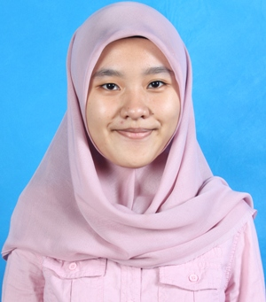**Full Name :** Ajeng Anugrah Lestari

**Sex :** Female

**Place, Date of Birth :** Bekasi, November 08th, 1992

**Nationality :** Indonesia

**Marital Status :** Single

**Height, Weight :** 158 cm, 54 kg

**Address :** Villa Pertiwi Blok I5 No.1

RT/RW: 001/015, Depok

16415, West Java

**Mobile :** +6287779160925

**Phone :** +622129250046

**E-mail :** [ajeng.alestari@gmail.com](mailto:ajeng.alestari@gmail.com)

|  |
| --- |
| OBJECTIVE |

I aim to contribute the practical experience of work opportunity. Aware of the competition, I am ready to learn and have trained myself to adapt and develop in tough condition.

|  |
| --- |
| EDUCATION |

**FORMAL**

2010-present Completing Bachelor Degree at Universitas Indonesia, Depok,

West Java-Indonesia.

Major: Information Systems

Temporary Cumulative GPA: 3.25 out of 4.00

July 2007-June 2010 SMA Negeri 7 Jakarta, Indonesia

July 2004-June 2007 SMP Putra 1 Jakarta, Indonesia

July 1998-June 2004 SD Islam Al-Azhar 06 Jakapermai, Indonesia

July 1997-June 1998 TK Tunas Jakasampurna, Indonesia

**INFORMAL**

2000-2004 English course at NEW CONCEPT

2007-2008 English course at EF Kalimalang

2008-2010 English course at LBPP LIA Kalimalang

|  |
| --- |
| SKILLS |

* LANGUAGE : Bahasa Indonesia (Native)

Good command of English, both oral and written

Programming language (Java, PHP, Javascript, HTML, and CSS)

* COMPUTER : Able to use Ms.Office (Ms. Word, Ms. Excel, Ms. Power Point)

Able to use developer tools (Eclipse, NetBeans, Notepad++, Scite, CodeCharge Studio)

Able to use database (MySQL and PostgreSQL)

Able to use ERP and SCM tool (SAP R3)

Able to use application Lindo and Multisim

|  |
| --- |
| WORK and ACTIVITY EXPERIENCES |

2013 Web developer of <http://ihsancatering.com>

2013-present System Analyst in Enhanced Media Monitoring Analyzer

|  |
| --- |
| ORGANIZATIONAL EXPERIENCES |

2008-2009 Treasurer of Science Club SMA Negeri 1 Depok

2008-2009 Head of Traditional Club SMA Negeri 71 Jakarta

2010-2012 Head of Traditional Club in Faculty of Computer Science, Universitas Indonesia

2011-2012 Deputy of Teater Biru Merah in Faculty of Computer Science, Universitas Indonesia

2013-present Coordinator of Internal Division in Executive Institution of Student

|  |
| --- |
| OTHER ACHIEVEMENTS |

* Won the 1st prize of Science Battle in Al-Azhar 2 Jakarta, 2007
* 10 Finalist of Science Olympiad in Depok, 2008
* Participant in National Mathematics Competition held by Universitas Gadjah Mada, 2008
* Participant in Quick Race for Celebrating Indonesia Spatial Day, 2009
* Indonesia Delegation in Sunburst Youth Camp, 2009

|  |
| --- |
| MEMBERSHIP IN COMMITTEE |

2011 Staff of Communication in Orientasi Kehidupan Kampus, Universitas Indonesia

2011 Staff of Fund Raising in Computes Get Together 2011, held by Faculty of Computer Science, Universitas Indonesia

2011 Staff of Sponsorship in Computer Festival 2011, held by Faculty of Computer Science, Universitas Indonesia

2011 Staff of Event in Penerimaan Mahasiswa Baru Faculty of Computer Science, Universitas Indonesia

2012 PIC of Fund Raising in Computes Get Together 2012, held by Faculty of Computer Science, Universitas Indonesia

2012 PIC of Discplinary Committee in Penerimaan Mahasiswa Baru Faculty of Computer Science, Universitas Indonesia

|  |
| --- |
| SEMINARS AND TRAININGS |

* Training for Emotional Spiritual Quotient, July 2010
* Android Seminar held by Faculty of Computer Science Universitas Indonesia, August 2010
* Training with theme “Lejitkan Potensi”, January 2011
* Training with theme “Mengelola Hidup dan Merencanakan Masa Depan”, January 2012
* Training for developing scientific writing, June 2012
* Training for developing “Proposal Program Kreativitas Mahasiswa”, October 2012

|  |
| --- |
| HOBBIES AND INTERESTS |

* Singing
* Listening to music
* Watching movie